CHAPTER 5
5. ELEMENTARY PROBABILITY
Introduction
- Probability theory is the foundation upon which the logic of inference is built.
- It helps us to cope up with uncertainty.
- In general, probability is the chance of an outcome of an experiment. It is the measure of how likely an outcome is to occur.
Definitions of some probability terms
  - Experiment: Any process of observation or measurement or any process which generates well defined outcome.
  - Probability Experiment: It is an experiment that can be repeated any number of times under similar conditions and it is possible to enumerate the total number of outcomes with out predicting an individual out come. It is also called random experiment.
Example: If a fair die is rolled once it is possible to list all the possible outcomes i.e.1, 2, 3, 4, 5, 6 but it is not possible to predict which outcome will occur.
  - Outcome :The result of a single trial of a random experiment
  - Sample Space: Set of all possible outcomes of a probability experiment
  - Event: It is a subset of sample space. It is a statement about one or more outcomes of a random experiment .They are denoted by capital letters.
Example: Considering the above experiment let A be the event of odd numbers, B be the event of even numbers, and C be the event of number 8.
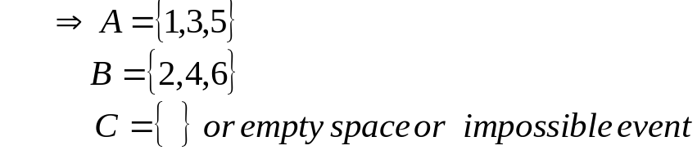
Remark:
If S (sample space) has n members then there are exactly 2^{n} subsets or events.
  - Equally Likely Events: Events which have the same chance of occurring.
  - Complement of an Event: the complement of an event A means non- occurrence of A and is denoted by 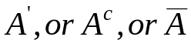 contains those points of the sample space which don’t belong to A.
  - Elementary Event: an event having only a single element or sample point.
  - Mutually Exclusive Events: Two events which cannot happen at the same time.
  - Independent Events: Two events are independent if the occurrence of one does not affect the probability of the other occurring.
  - Dependent Events: Two events are dependent if the first event affects the outcome or occurrence of the second event in a way the probability is changed.

Example: .What is the sample space for the following experiment

- Toss a die one time.
- Toss a coin two times.
- A light bulb is manufactured. It is tested for its life length by time.
Solution
- S={1,2,3,4,5,6}
- S={(HH),(HT),(TH),(TT)}
- S={t /t≥0}
  - Sample space can be

    - Countable ( finite or infinite)
    - Uncountable.
Counting Rules
In order to calculate probabilities, we have to know
- The number of elements of an event
- The number of elements of the sample space.
That is in order to judge what is probable, we have to know what is possible.
- In order to determine the number of outcomes, one can use several rules of counting.
  - The addition rule
  - The multiplication rule
  - Permutation rule
  - Combination rule

- To list the outcomes of the sequence of events, a useful device called tree diagram is used.

Example: A student goes to the nearest snack to have a breakfast. He can take tea, coffee, or milk with bread, cake and sandwitch. How many possibilities does he have?

Solutions:

Tea
Bread
Cake
Sandwich

Coeffee
Bread
Cake
Sandwitch

Milk

Bread
Cake
Sandwitch

➔ There are nine possibilities.

The Multiplication Rule:

If a choice consists of k steps of which the first can be made in n₁ ways, the second can be made in n₂ ways…, the k^{th} can be made in n_{k} ways, then the whole choice can be made in 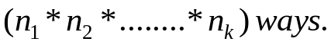
Example: The digits 0, 1, 2, 3, and 4 are to be used in 4 digit identification card. How many different cards are possible if
- Repetitions are permitted.
- Repetitions are not permitted.
Solutions

1st digit | 2nd digit | 3rd digit | 4th digit
5 | 5 | 5 | 5
There are four steps
- Selecting the 1st digit, this can be made in 5 ways.
- Selecting the 2nd digit, this can be made in 5 ways.
- Selecting the 3rd digit, this can be made in 5 ways.
- Selecting the 4th digit, this can be made in 5 ways.
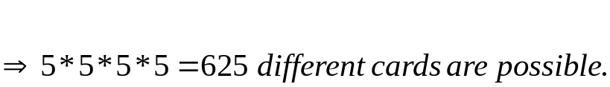

1st digit | 2nd digit | 3rd digit | 4th digit
5 | 4 | 3 | 2

There are four steps
- Selecting the 1st digit, this can be made in 5 ways.
- Selecting the 2nd digit, this can be made in 4 ways.
- Selecting the 3rd digit, this can be made in 3 ways.
- Selecting the 4th digit, this can be made in 2 ways.
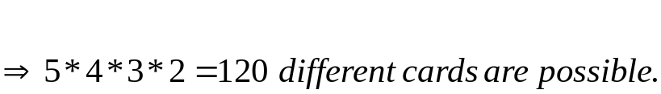

Permutation

An arrangement of n objects in a specified order is called permutation of the objects.
Permutation Rules:
- The number of permutations of n distinct objects taken all together is n!
Where
- The arrangement of n objects in a specified order using r objects at a time is called the permutation of n objects taken r objects at a time. It is written as 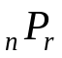 and the formula is
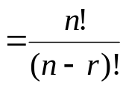

- The number of permutations of n objects in which k₁ are alike k₂ are alike ---- etc is

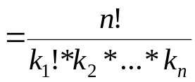
Example:
- Suppose we have a letters A,B, C, D
  - How many permutations are there taking all the four?
  - How many permutations are there two letters at a time?
- How many different permutations can be made from the letters in the word “CORRECTION”?
Solutions:

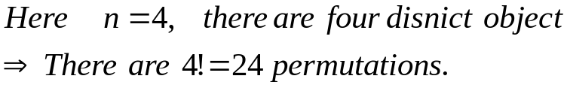

  - 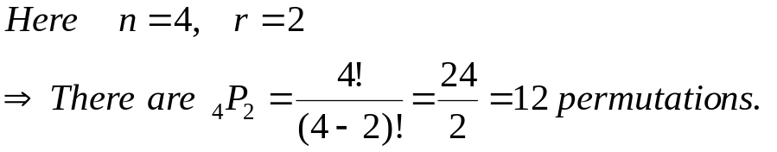

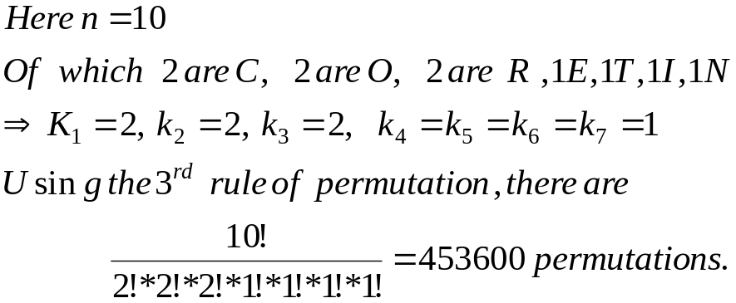
Exercises:
- Six different statistics books, seven different physics books, and 3 different Economics books are arranged on a shelf. How many different arrangements are possible if;
  - The books in each particular subject must all stand together
  - Only the statistics books must stand together
- If the permutation of the word WHITE is selected at random, how many of the permutations
    - Begins with a consonant?
    - Ends with a vowel?
    - Has a consonant and vowels alternating?
Combination

A selection of objects with out regard to order is called combination.
Example: Given the letters A, B, C, and D list the permutation and combination for selecting two letters.

Solutions:
Permutation Combination
AB | BC
AC | BD
AD | DC
AB | BA | CA | DA
AC | BC | CB | DB
AD | BD | CD | DC

Note that in permutation AB is different from BA. But in combination AB is the same as BA.

Combination Rule

The number of combinations of r objects selected from n objects is denoted by 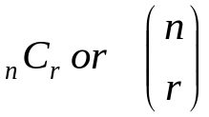 and is given by the formula:

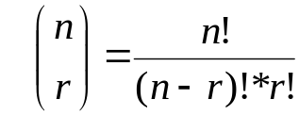
Examples:
- In how many ways a committee of 5 people be chosen out of 9 people?
Solutions:

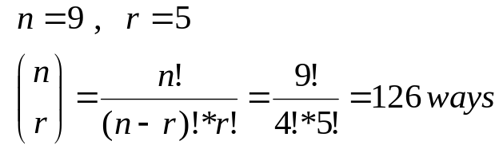
- Among 15 clocks there are two defectives .In how many ways can an inspector chose three of the clocks for inspection so that:
  - There is no restriction.
  - None of the defective clock is included.
  - Only one of the defective clocks is included.
  - Two of the defective clock is included.

Solutions:

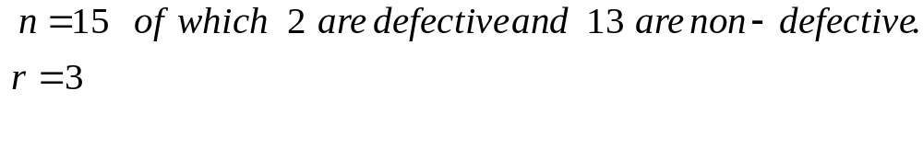
- If there is no restriction select three clocks from 15 clocks and this can be done in :
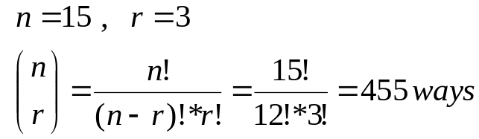

- None of the defective clocks is included.
This is equivalent to zero defective and three non defective, which can be done in:

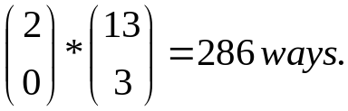
- Only one of the defective clocks is included.
This is equivalent to one defective and two non defective, which can be done in:

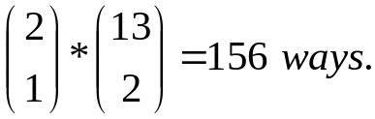
- Two of the defective clock is included.
This is equivalent to two defective and one non defective, which can be done in:

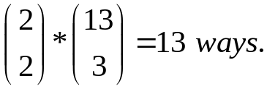

Exercises:
- Out of 5 Mathematician and 7 Statistician a committee consisting of 2 Mathematician and 3 Statistician is to be formed. In how many ways this can be done if
  - There is no restriction
  - One particular Statistician should be included
  - Two particular Mathematicians can not be included on the committee.
- If 3 books are picked at random from a shelf containing 5 novels, 3 books of poems, and a dictionary, in how many ways this can be don if
  - There is no restriction.
  - The dictionary is selected?
  - 2 novels and 1 book of poems are selected?

Approaches to measuring Probability
There are four different conceptual approaches to the study of probability theory. These are:
- The classical approach.
- The frequentist approach.
- The axiomatic approach.
- The subjective approach.

The classical approach

This approach is used when:
- All outcomes are equally likely.
- Total number of outcome is finite, say N.
Definition: If a random experiment with N equally likely outcomes is conducted and out of these N_{A} outcomes are favourable to the event A, then the probability that event A occur denoted 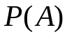 is defined as:
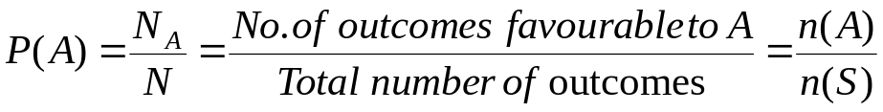

Examples:
- A fair die is tossed once. What is the probability of getting
  - Number 4?
  - An odd number?
  - An even number?
  - Number 8?
Solutions:
First identify the sample space, say S
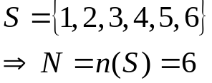
- Let A be the event of number 4
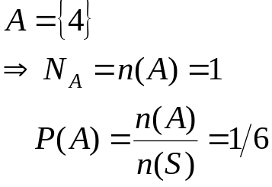

- Let A be the event of odd numbers
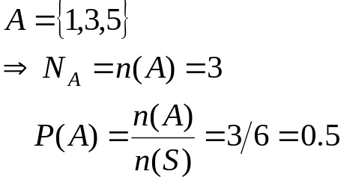

- Let A be the event of even numbers
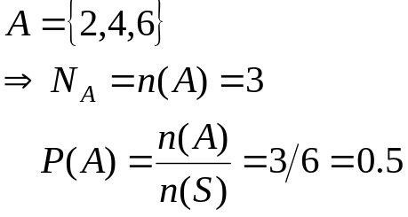
- Let A be the event of number 8
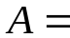 Ø

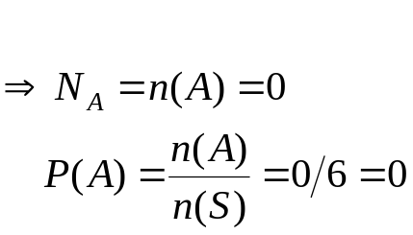
- A box of 80 candles consists of 30 defective and 50 non defective candles. If 10 of this candles are selected at random, what is the probability
- All will be defective.
- 6 will be non defective
- All will be non defective

Solutions:
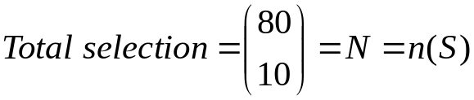
- Let A be the event that all will be defective.

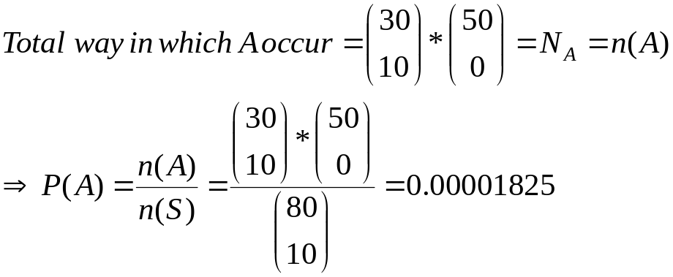

- Let A be the event that 6 will be non defective.
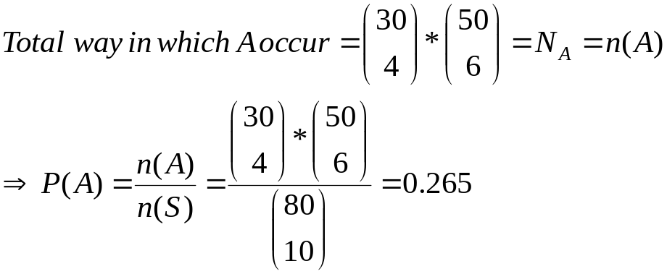
- Let A be the event that all will be non defective.

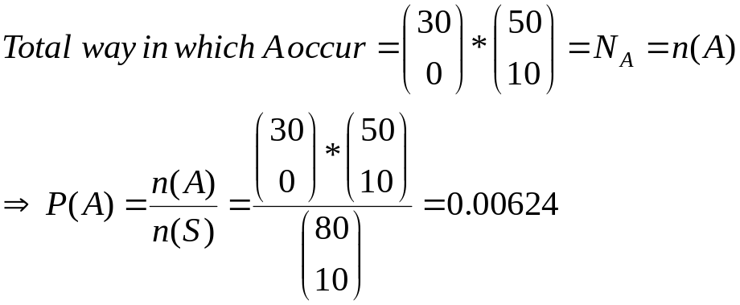

Exercises:
- What is the probability that a waitress will refuse to serve alcoholic beverages to only three minors if she randomly checks the I.D’s of five students from among ten students of which four are not of legal age?
- If 3 books are picked at random from a shelf containing 5 novels, 3 books of poems, and a dictionary, what is the probability that
  - The dictionary is selected?
  - 2 novels and 1 book of poems are selected?

Short coming of the classical approach:
This approach is not applicable when:
- The total number of outcomes is infinite.
- Outcomes are not equally likely.

The Frequentist Approach
This is based on the relative frequencies of outcomes belonging to an event.
Definition: The probability of an event A is the proportion of outcomes favourable to A in the long run when the experiment is repeated under same condition.
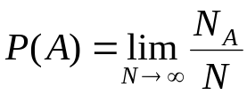
Example: If records show that 60 out of 100,000 bulbs produced are defective. What is the probability of a newly produced bulb to be defective?
Solution:
Let A be the event that the newly produced bulb is defective.
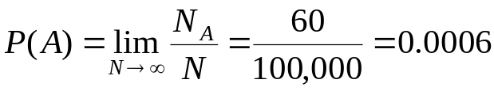

Axiomatic Approach:

Let E be a random experiment and S be a sample space associated with E. With each event A a real number called the probability of A satisfies the following properties called axioms of probability or postulates of probability.
- 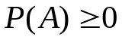
- 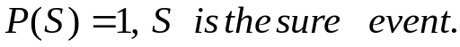
- If A and B are mutually exclusive events, the probability that one or the other occur equals the sum of the two probabilities. i. e. 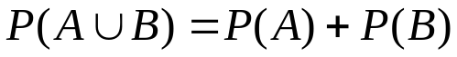
- 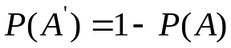
- 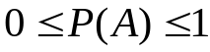
- P(ø) =0, ø is the impossible event.
Remark: Venn-diagrams can be used to solve probability problems.
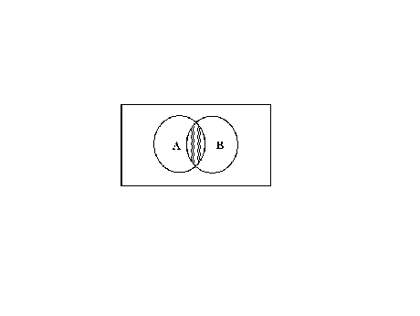
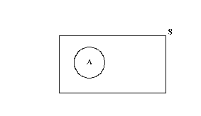


A U B A n B A

In general

Conditional probability and Independency
Conditional Events: If the occurrence of one event has an effect on the next occurrence of the other event then the two events are conditional or dependant events.

Example: Suppose we have two red and three white balls in a bag
- Draw a ball with replacement
Let A= the event that the first draw is red➔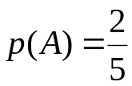
B= the event that the second draw is red ➔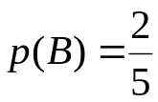
A and B are independent.
- Draw a ball with out replacement
Let A= the event that the first draw is red➔
B= the event that the second draw is red ➔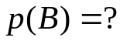
This is conditional.
Let B= the event that the second draw is red given that the first draw is red ➔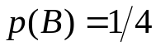

Conditional probability of an event

The conditional probability of an event A given that B has already occurred, denoted 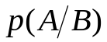 is
=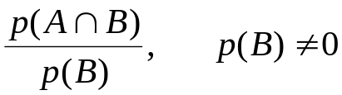
Remark: (1) 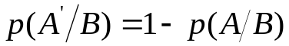
(2) 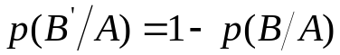

Examples
- For a student enrolling at freshman at certain university the probability is 0.25 that he/she will get scholarship and 0.75 that he/she will graduate. If the probability is 0.2 that he/she will get scholarship and will also graduate. What is the probability that a student who get a scholarship graduate?

Solution: Let A= the event that a student will get a scholarship
B= the event that a student will graduate
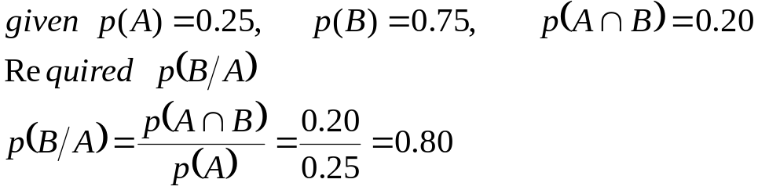
- If the probability that a research project will be well planned is 0.60 and the probability that it will be well planned and well executed is 0.54, what is the probability that it will be well executed given that it is well planned?
Solution; Let A= the event that a research project will be well
Planned
B= the event that a research project will be well
Executed
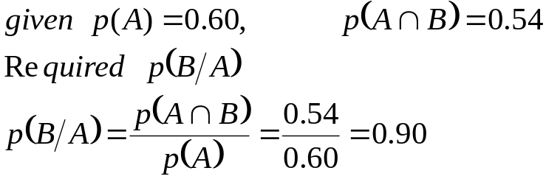

- A lot consists of 20 defective and 80 non-defective items from which two items are chosen without replacement. Events A & B are defined as A = {the first item chosen is defective}, B = {the second item chosen is defective}
  - What is the probability that both items are defective?
  - What is the probability that the second item is defective?
Solution; Exercise

Note; for any two events A and B the following relation holds.

Probability of Independent Events

Two events A and B are independent if and only if 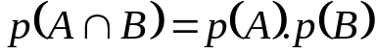
Here
Example; A box contains four black and six white balls. What is the probability of getting two black balls in drawing one after the other under the following conditions?
- The first ball drawn is not replaced
- The first ball drawn is replaced
Solution; Let A= first drawn ball is black
B= second drawn is black
Required 